Technical Report

**Functional Specification**

**Frode Karlsen**

**Word count**

Summary: 112 | Main text: 1574

Table of Contents

1. Summary …….……………………………………….3

2. Body

2.1 Introduction…………………………………….….4

2.2 Main…………………………………………….4-15

i. Planning ….……………………………….4-5

ii. Functional specification ………………..6-13

iii. Gantt creation ……………………………..14

iv. Intellectual property ..…………………….15

2.3 Conclusion ………………………………………15

3. References ………………………………………...16

1. Summary

For the project exam, I am going to make a microsite for NASA. The main focus of the site is the Hubble Telescope and its 30th anniversary, which is this year. The page will mostly contain stunning images that the Hubble Telescope has taken, videos and interesting articles published by NASA. I am going to work on a concept that will broaden the target audience of the page. An example of this is that I am going to use stunning images that people can use as their backgrounds on their smart phones, tablets and PCs.   
  
This report includes a project plan, functional specification and a Gantt chart creation process for this project.

2. Body

2.1 Introduction

Since I am the only one that is going to work on this project, I did not create a team, like we did in the previous task where we created a Gantt chart.

2.2 Main

i. Planning

To start with I created user stories and gave them all an ID from 1 to 26:

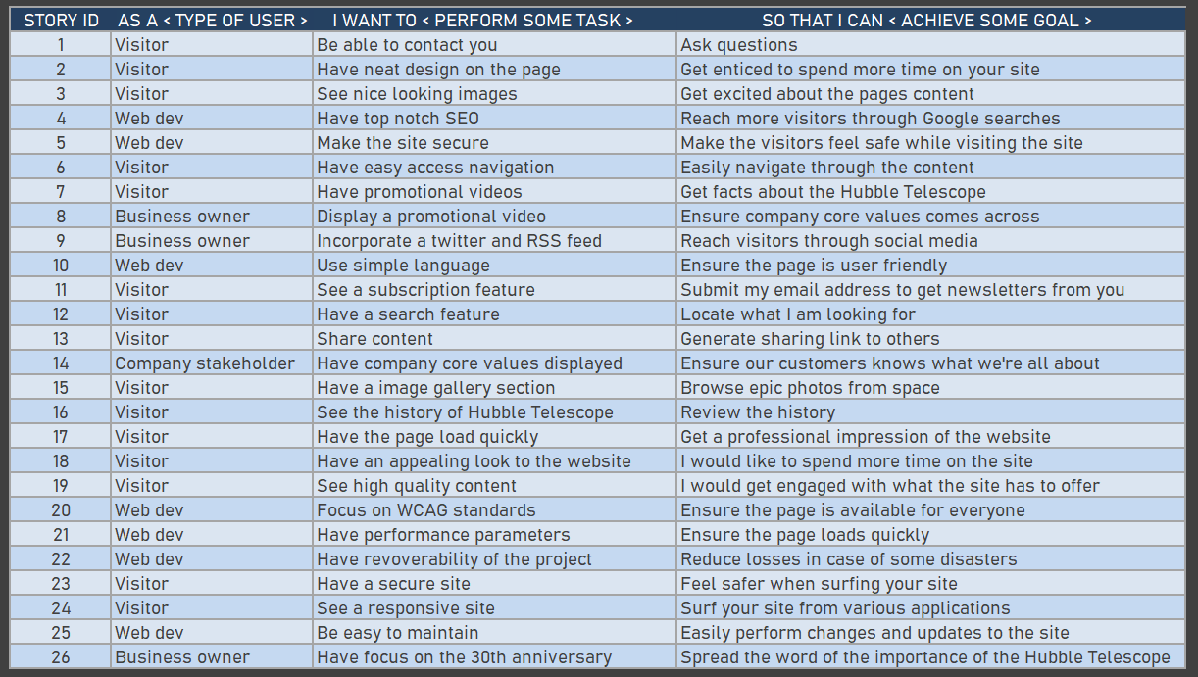

The general idea in the planning phase was to get these sorted and divided, but to keep things simple I put the development plan in four initial phases: planning phase, design phase, development phase and testing & launch. Instead of having all microtasks listed inside the Gantt chart, I decided to make them less specific in my task list, but note the smaller tasks into the ‘schedule’ section of the Gantt to describe what should be done during each task section. With that in mind I created 6 main tasks and split them up into smaller tasks into the Gantt chart:

* **Planning**: functional specification, gantt chart.
* **Research**: general research, target audience, card sorting, information architecture, personas, scenarios and storyboards.
* **Design**: general research, layouts and images, fonts and colors, navigation design and interaction design.
* **Wireframe**: wireframe creation and prototyping.
* **Programming:** research & content creation, front page (HTML&CSS base), image of the day page (HTML&CSS base), image gallery & video page (HTML&CSS base), article page (HTML&CSS base), choosing relevant API, JS coding, HTML review, CSS review, @media coding.
* **Implementation:** bugfix, user testing, rollout and report writing.

I have also created a weekly schedule from week 1 to 5 and split up into daily workplan for each smaller task. Upon completion the scheduled task will get a red color when done to display progress of the project, which is displayed in the Gantt chart provided in this deliverable task.

ii. Functional Specification

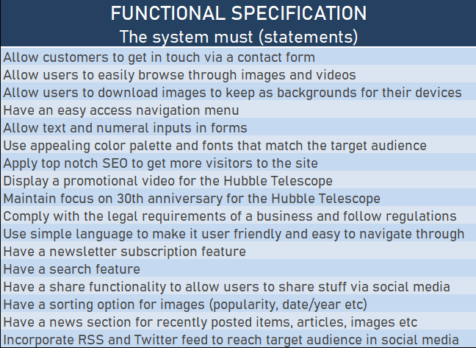

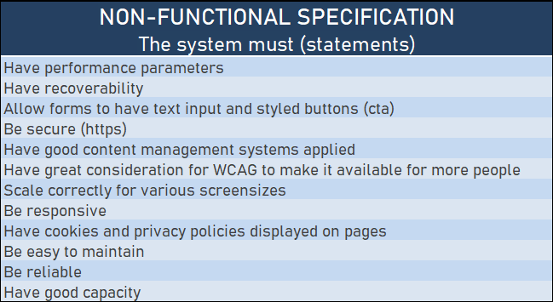

Themes

1. **The Hubble Telescope’s 30th anniversary**

This is the main goal of the microsite. I simply want a site that celebrates the 30 years of the Hubble’s existence. The microsite will contain interesting articles, but in particular have a clear focus of the fantastic images the telescope has taken and details behind the images.

1. **Social media presence**

This is another focus area of the microsite. Here I plan to have an RSS feed on the page and twitter feed directly from NASA. Visitors are also allowed to share stunning images on their Facebook page, download images as backgrounds to their smart phones/tables/PCs and rate images. Another idea to spread the page through social media would be to have quizzes with prizes such as NASA t-shirts and other apparel.

1. **Display company core values**

NASA is all about integrity, safety, teamwork and excellence. These core values are set in stone to ensure successful missions. However, they are in the end all about exploration, curiosity and education. Their work is a study of the universe we live in and space exploration. I will focus on finding our inner child via imagination. Who hasn’t pretended to be an astronaut as a kid?

The Hubble Telescope’s 30th anniversary

|  |  |
| --- | --- |
| Feature | Website Design |

Epics

* As a visitor, I want an appealing website, so that I will get engaged by its content.
* As a visitor, I want engaging content, so that I will stay longer on the site.

User Stories

* As a visitor, I want nice images displayed, so that I will get enticed to browse through the content on your website.
* As a web dev, I want a nice looking website, so that we can represent NASA in the best way possible to the public.
* As a web dev, I want a nice layout that emphasises the most important parts of the pages.
* As a web dev, I want the company colors to shine through, so that it feels familiar to the users.
* As a web dev, I want to see easy to read fonts, but still make it familiar to NASA, to ensure people understand who we are representing here.

|  |  |
| --- | --- |
| Feature | Search |

Epics

* As a visitor, I want a search functionality, so that I can quickly navigate through the pages content.

User Stories

* As a web dev, I want a search icon displayed in the navigation, so that it’s both easy to locate and practical for the users.
* As a visitor, I want a search functionality, so that I am able to search through specific content of the site to find what I am looking for.

|  |  |
| --- | --- |
| Feature | Navigation |

Epics

* As a visitor, I want a navigation menu, so that I can easily browse through your pages.
* As a web dev, I want a navigation menu, so that our website looks professional.

User Stories

* As a visitor, I want a nice looking navigation menu, so that I swiftly can browse through the various pages/sections of the site.
* As a web dev, I would like the navigation menu to include a search bar so that users can swiftly search through the pages contents.
* As a web dev, I want a hamburger menu for mobile and smaller resolutions, in order to maintain easy navigation on the site.

|  |  |
| --- | --- |
| Feature | Contact Form |

Epics

* As a visitor, I want a contact form, so that I can get in touch with you in case I have any questions.

User Stories

* As a visitor, I want a contact form, so that I can get in touch with you if I have any questions or leave feedback.
* As a web dev, I would like our visitors to be able to contact us, so that we are in better touch with the customer base.
* As a visitor, I would like confirmation that the message have been sent and average response time, so that I can be notified about this.

Social Media Presence

|  |  |
| --- | --- |
| Feature | Image of the day |

Epics

* As a visitor, I would like an image of the day section, so that I can see fantastic images every day on your page.

User Stories

* As a web dev, I want the Image of the Day section to be available in the navigation, for easy access to our visitors.
* As a visitor, I want to be able to share and download these images, so that I can share them through social media, or use them as a background on my phone/tablet or PC.
* As a web dev, I want to have an API call made for this section, in order to ensure that the page updates itself daily via a JavaScript.

|  |  |
| --- | --- |
| Feature | Quiz |

Epics

* As a visitor, I would like a quiz section, so that I can take part on quizzes on your page.
* As a web dev, I would like to create a quiz to better interact with the visitors.

User Stories

* As a web dev, I would like to make a quiz for our visitors with prizes such as NASA t-shirts and apparel to spread the word about the page.

|  |  |
| --- | --- |
| Feature | Twitter/RSS Feed |

Epics

* As a visitor, I would like to see twitter and RSS feeds with news from NASA.

User Stories

* As a web dev, I want to implement twitter and RSS feeds to better interact with our visitors to keep them posted on news from NASA.
* As a visitor, I want RSS/Twitter feeds to keep up to date with news from NASA on your site.

|  |  |
| --- | --- |
| Feature | Social Media Links |

Epics

* As a visitor, I want easy access to social media links, so that I can easily locate NASA on social media.

User Stories

* As a web dev, I would like to provide easy to find social media links, so that visitors can review NASAs social media accounts.

Company core values

|  |  |
| --- | --- |
| Feature | Promotional Video |

Epics

* As a visitor, I would like a promotional video, so that I can see what the Hubble Telescope is all about.

User Stories

* As a web dev, I would like to have a promotional video on display, so that visitors easily can see a video what the Hubble Telescope is all about.

|  |  |
| --- | --- |
| Feature | History |

Epics

* As a visitor, I would like to read about the Hubble Telescope’s history, so that I can see where it all started.

User Stories

* As a web dev, I would like to give our visitors the opportunity to see the history of the Hubble Telescope through a visual timeline.

iii. Gantt creation

As for the Gantt chart and the creation process, I simply revamped the one I created for our CA in the Project Methodology course. I changed up the colors, but as for the main structure and design it remained the same.

I put up estimations as per your example from the Project Exam Deliverables/Milestones:

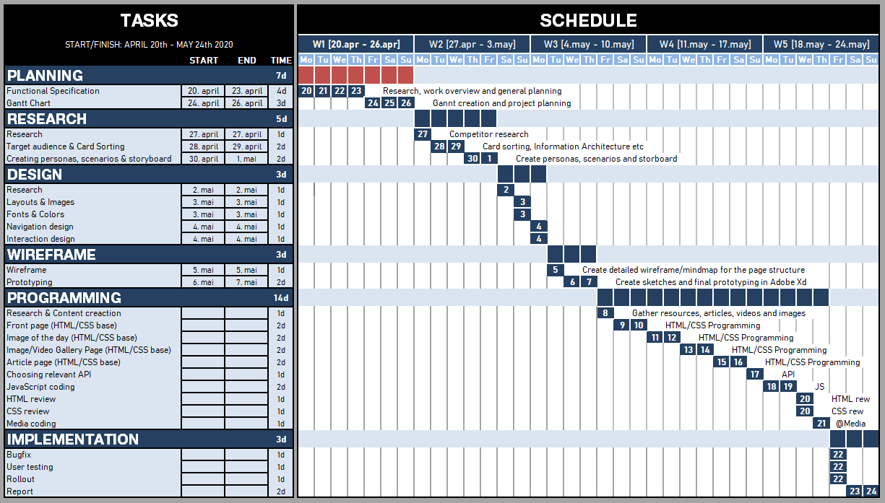

The red color inside the schedule indicates finished tasks, while the blue is unfinished tasks. This makes the project easy to follow in regards to progression. I have not taken any days off, but I usually take it slow on Monday. I also have my own birthday on the 6th of May, while my father have his on the 16th of May, so those will probably be a bit slower in terms of workload. The rest is pretty self explanatory to be honest.

iv. Intellectual property

In order to ensure that the intellectual properties would be well protected, these are the steps I am going to take:

* Let people know that the content I am reciting are copyrighted by NASA, and refer to their guidelines about usage. I am making this as a copyright print on every page in a footer section (where applicable)

2.3 Conclusion

This report is showing my process throughout the planning phase of the project. It includes functional specification and a project plan (Gannt chart), themes and features. The project will get more detailed as I move on to the next two phases, which is research, design and wireframe. Once all that is done the programming will start. Finally I have set aside time to testing, rollout and report writing.

3. References

Gant chart downloadable via GitHub - (Gantt.xlsx):

<https://github.com/IamMattDamon/project_exam1/tree/master/functional%20spec>